Generalized Linear Model Lab
Preston Heen
2/24/2020
Methods
The data I used was from the Forest Inventory and Analysis Program, and I used data of Pinus edulis that was gathered from National Forest areas in the United States. The data was collected in New Mexico, Colorado, Utah, Arizona, and Texas. The purpose of this study was to see where Pinus edulis could be present using a generalized linear model. The covariates I used were precipitation, solar radiation, wind, and minimum temperature to find where the likelihood of the presence of Pinus edulis in the US. I used Bluespray to make the prediction using the points to raster function.
Table 1. Each model run

Model Run | Covariates | Model  Method | Model  Parameters
1 | MinTemp,  Precip | GLM | Binomial
2 | MinTemp,  Precip,  Wind | GLM | Binomial
3 | MinTemp,  Precip,  Wind,  Solar | GLM | Binomial

Results
In my results I made a surface model to predict where Pinus edulis could be present. My data showed the same thing for each predictor where as they increase, we can expect to see a decrease in Pinus edulis. As I added more covariates the AIC value decreased. I created a logistic regression to predict where the conditions are suitable habitat for Pinus edulis. 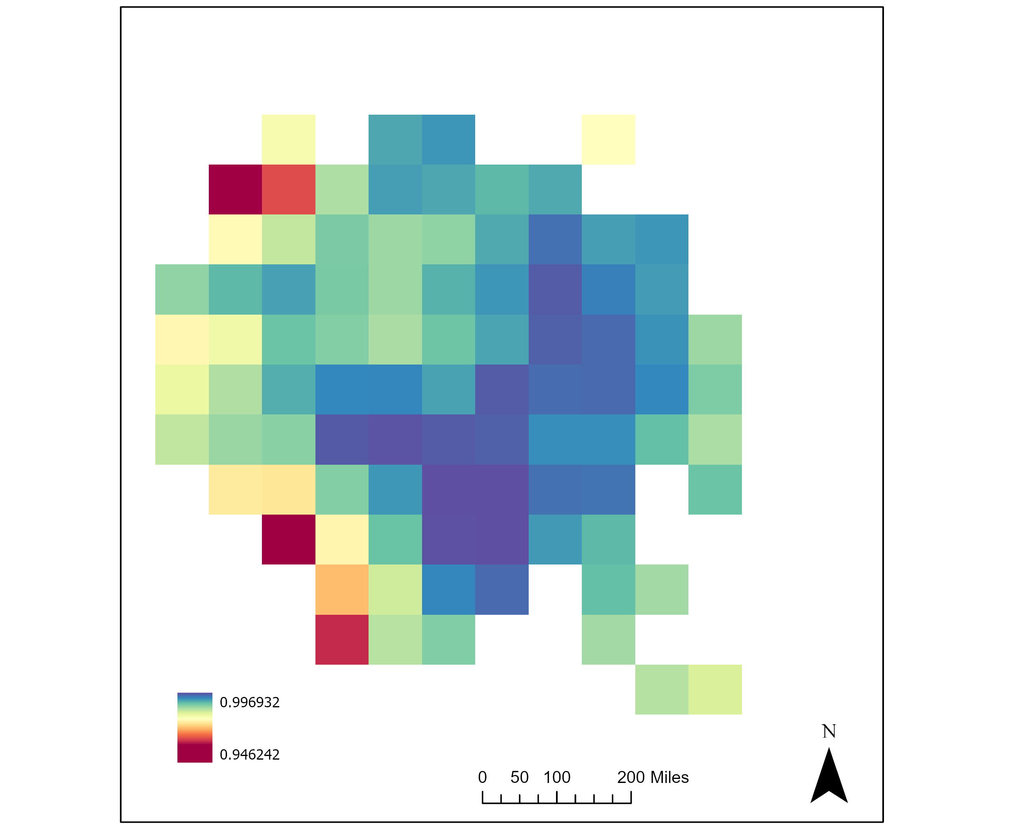
Figure 1. Modeled prediction of Pinus edulis in the Southwest United States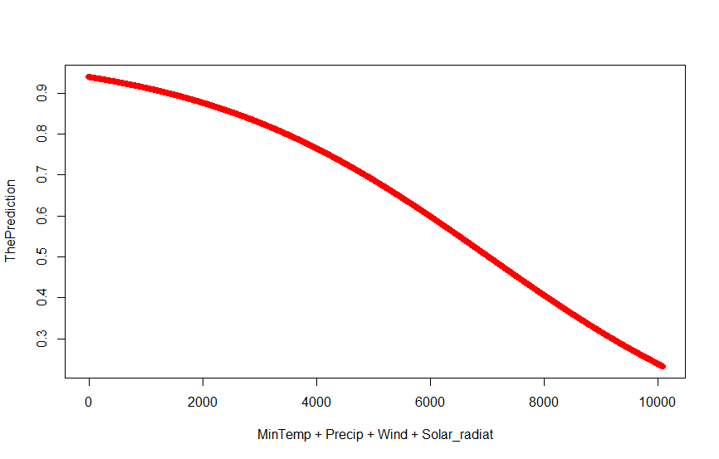
Figure 2. Model 3 Prediction
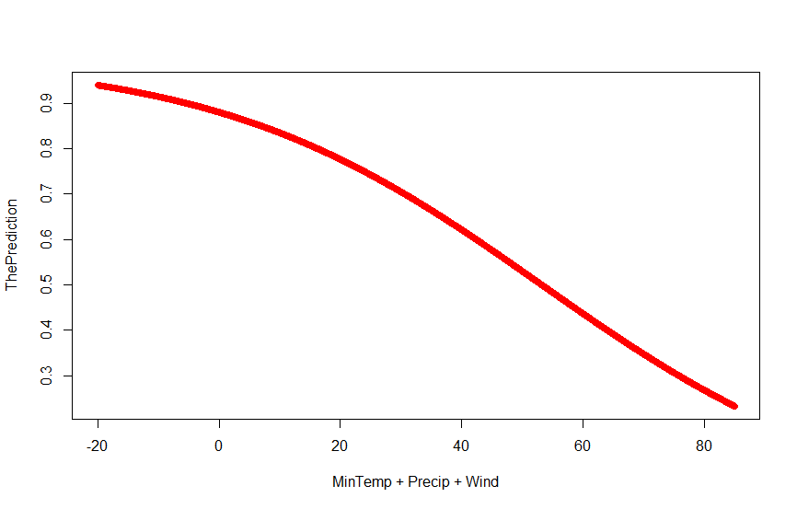
Figure 3. Model 2 Prediction
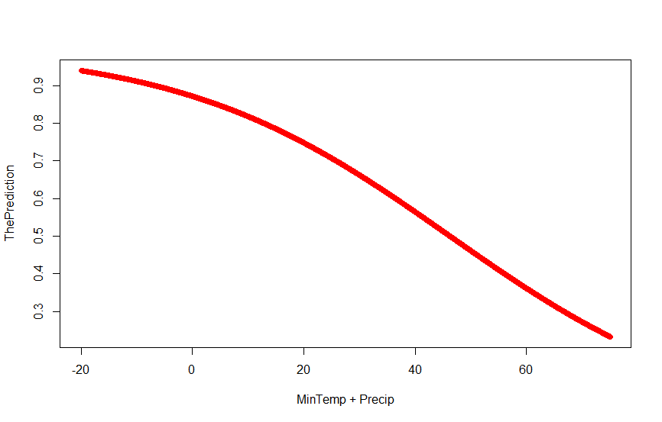
Figure 4. Model 1 Prediction

Table 4. Akaike Information Criterion for model comparison
Model Run | AIC value
1 | 1174.4
2 | 1174
3 | 1162.2

Conclusion
Model three is the model with the best AIC value. The data did not cover any points outside of the US, and were all in a national forest. This model could be better with more covariates and predictors. In the third prediction I did not include all the points in the solar radiation when creating the vector. The data also did not have presence or absence data, so I made one based on the plots from the FIA program.
Appendix
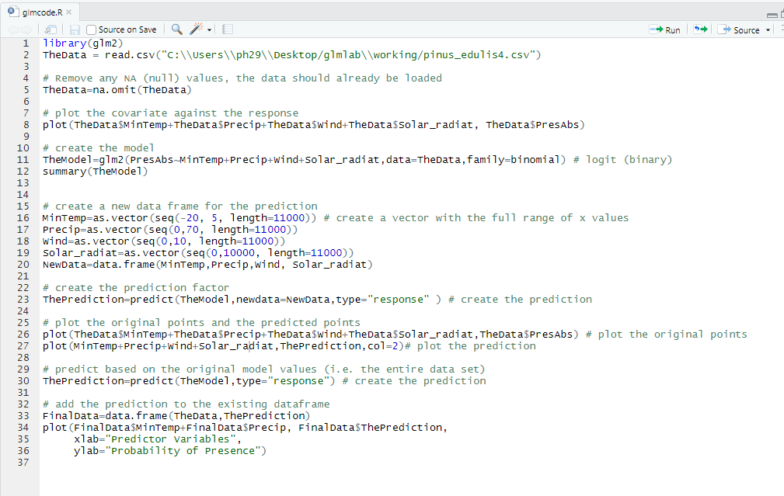
Figure A. Code for model

